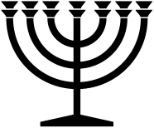 |  | April 2024
Sunday | Monday | Tuesday | Wednesday | Thursday | Friday | Saturday
 | 1 | 2 | 3 | 4 | 5 | 6
 |  | S
7 | 8 | 9 | 10 | 11 | 12 | 13
 |  | S | NM
14 | 15 | 16 | 17 | 18 | 19 | 20
 |  |  | S
21 | 22 | 23 | 24 | 25 | 26 | 27
 |  |  | Passover (After Previous Sunset)  S | ULB-2 | ULB-3 | ULB-4
28 | 29 | 30
ULB-5 | ULB-6 | Last Day of Unleavened Bread
RED = Sabbath BLUE = New Moon YELLOW = High Day Green & YELLOW = Days of Unleavened Bread www.hope-of-israel.org

