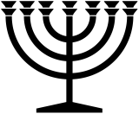 |  | July 2024
Sunday | Monday | Tuesday | Wednesday | Thursday | Friday | Saturday
 | 1 | 2 | 3 | 4 | 5 | 6
 |  |  |  |  |  | S
7 | 8 | 9 | 10 | 11 | 12 | 13
NM
14 | 15 | 16 | 17 | 18 | 19 | 20
S
21 | 22 | 23 | 24 | 25 | 26 | 27
S
28 | 29 | 30 | 31
S
RED = Sabbath BLUE = New Moon www.hope-of-israel.org

