Hope of Israel Ministries (Ecclesia of YEHOVAH):
The Stonehenge Giants
Whether in myth, legend, historical documents, massive effigies, or huge bones and skeletons being unearthed, the connection of giants to Stonehenge has been pressed upon the consciousness of this part of Britain for generations. Now, with all the information resurfacing, the age-old legends and myths may prove the famous stone circle had unorthodox origins, quite possibly built by the hands of giants.
by Hugh Newman
Stories of giants being involved in the construction of megalithic sites have been alive in the consciousness of the British for millennia. Legends and creation stories harken back to an earlier age of elemental beings, high magic and giant kings ruling the land. Religious documents, medieval chronicles, oral traditions and origin stories all recount converging tales of giants being an integral part of the founding of the British Isles.
Giant effigies are still paraded around many cities and towns, keeping this ancient memory alive. Mystics, sages and esoteric sources all speak of giants as a literal reality, often originating in a lost sunken realm. Even Stonehenge’s creation is attributed to remarkably tall and powerful builders. These titans were not only giant in stature, but also giants in intelligence, skill and wisdom.
Collating hundreds of historical accounts of massive bones and skeletons being found in the vicinity of sites such as Stonehenge adds some credence to the idea that age-old myths encoded detailed histories and insights from many thousands of years ago. These giants were often linked with the secret arts, forgotten sciences and magic from a fabled “Golden Age.”
The epic annals of Ireland, secret Scottish archives, old manuscripts of Wales and Druidic traditions of England have revealed a lost timeline, a missing chapter in human history that provides evidence of giant human beings inhabiting, ruling and building the megalithic masterworks of Albion.
The reality of giants existing in prehistoric times is put under the microscope in the new book The Giants of Stonehenge and Ancient Britain [1], with the investigation of obscure newspaper accounts, antiquarian diaries, archaeological reports, local history records, newly translated ancient texts, royal engineering survey data, academic papers, and written evidence from hundreds of sources going back several thousand years.
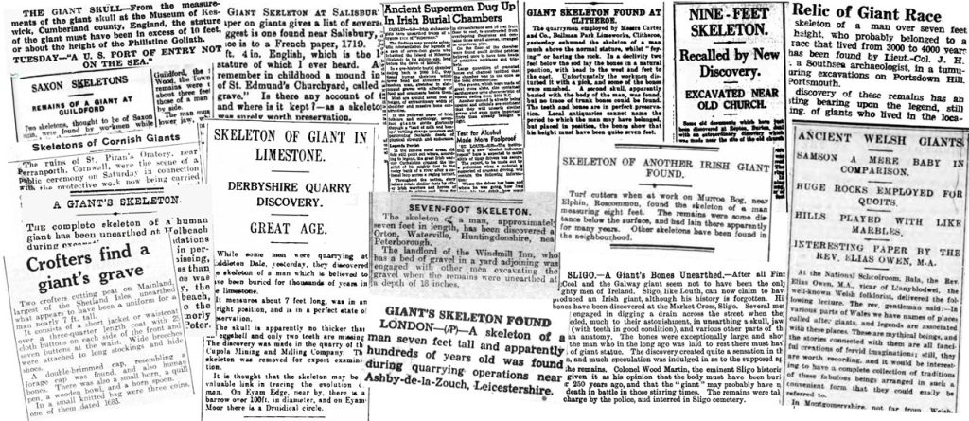

The Dragon Man, Denisovans and a slowly shifting paradigm
Before we explore the mysterious origins of Stonehenge, we’d like to point out a remarkable find that significantly strengthens the possibility of giants being a reality in prehistory. An enormous skull was found in China which has been named the “Dragon Man,” [2] a description derived from the Long Jiang or Dragon River in the Heilongjiang province of China. The skull was actually found in 1933 by a farmer who hid it in a well from Japanese soldiers. He shared the location of the skull with his grandson in 2018 who brought it to Chinese scientists.
While some believe it may be a new human ancestor, the consensus appears to be that it is a Denisovan skull and has been scientifically established to be at least 146,000 years old. What is remarkable is that it is the largest Homo skull ever found.
Chris Stringer, a highly respected anthropologist at the Natural History Museum in London stated on the BBC website, “This is the biggest human skull I’ve seen -- and I’ve seen a few.” [3] The notion that our ancestors were smaller with less cranial capacity may finally be changing, especially as Denisovan skull fragments, teeth and finger-bones have all been unearthed in Siberia and are of extraordinary size, compared to modern humans.

Were Giant Skeletons unearthed in the Greater Stonehenge Landscape?
Wiltshire contains some of the world’s most important megalithic sites, and many have giant associations at their core. Numerous “Giants Graves” are scattered across this county as mounds, long barrows and monoliths.
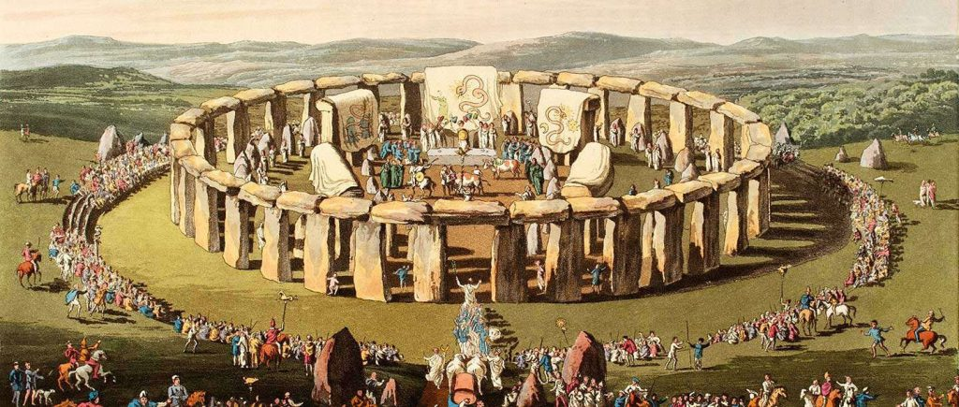
Imagined Druid festival at Stonehenge, 1815, by C.H. Smith and S.R. Meyrick
Historia Regum Britanniae, (The History of the Kings of Britain) [4] is a controversial historical account of British history written around 1136 by Geoffrey of Monmouth. It describes the most famous Arthurian tales and speaks frequently of giants. However, it is the telling of the story of the origins of Stonehenge (and the giants involved) that we will focus on here.
The book explains that Merlin built a burial place for Aurelius Ambrosius, an ancient King and that the stones, originally transported by giants from Africa, were erected into a stone ring in Ireland. A long time later, they were transported to Salisbury Plain by Merlin. We now know the bluestones came from West Wales, but the book highlights that it was known for a long time that they were from the western part of Britain.
The original name for Stonehenge was Chorea gigantum, (“The Giant’s Dance”). Stonehenge is a later Saxon name that roughly translates to “The Hanging Stones.” Another traditional Welsh name for Stonehenge is Côr y Cewri or “Council of the Giants.”
The earliest illustration of Stonehenge shows two average-sized gentlemen watching a giant lift one of the lintels into place. He is estimated to be about 16 feet tall based upon the known dimensions of Stonehenge. The twelfth-century story that this image comes from is a manuscript called Le Roman de Brut by Robert Wace thought originally to be dated to around 1155 AD. [5] This is a paraphrased version of Geoffrey’s Histories. It is the earliest illustration of the stones and appears to show Merlin, King Ambrosius and a giant.
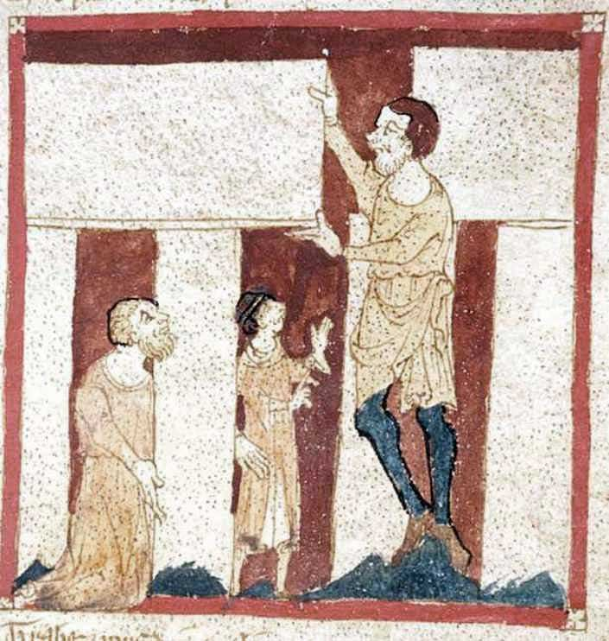
Illustration from Le Roman de Brut by poet Wace c.1155 AD showing a giant, Merlin and King Ambrosius
In Chapter Ten of Geoffrey’s Histories, King Aurelius is advised by Merlin to bring over the stones from an important megalithic site in Ireland called Killaraus. The stones were said to have been chosen for a very specific purpose, as healing stones of great sanctity. In the Histories Merlin states:
“They are mystical stones and of a medicinal virtue. The giants of old brought them from the farthest coast of Africa, and placed them in Ireland, while they inhabited that country. Their design in this was to make baths in them when they should be taken with any illness. For their method was to wash the stones and put their sick into the water, which infallibly cured them…There is not a stone there which has not some healing virtue.”
Gerion the Giant
In the year 1883 B.C. an invasion of Spain took place from the confines of North Africa. Having become a civilized land and wealthy due to changes in climate and the presence of many producing gold mines, Spain aroused the greed of Egypt and other North African nations. A king by the name of GERION or DEABUS, with a large army and many ships, conquered Spain and forced the inhabitants to dig gold for their new African overlords. Many Spanish slaves died from overwork under this tyranny.
Records Herman L. Hoeh in his Compendium of World History [6] --
"The history of this period is as follows:
“Gerion the Giant (1883-1849)
"Gerion was the seventh generation from Ham. He descended through Cush, Saba (the Saba of Gen. 10:7), Gog, Triton, Ammon and Hiarba (compare the last name with the Biblical ‘ARBA’ of Joshua 13:14, who was the father of the Anakim Giants).
“The Lomnini (1849-1807)
"The Lomnini were three GIANT SONS of Gerion. They were allowed to continue to rule in the land [Spain] after an invasion in 1849 by an Egyptian army under Osyris Denis (Dionysius in Greek)."
The Egyptians slew Gerion in 1849, whereupon the part of his tribe that was left fled to sea in their ships and sailed to the New World. A tradition found among the Toltecs of Mexico, and preserved by Ixtlilxochitl, declares that at one time there were GIANTS in their land.
Continues Herman Hoeh:
"Even the date of the arrival of these GIANTS has been preserved by the Toltec historian. It was 520 years after the flood. (Bancroft, Native Races of the Pacific States, vol. v, p. 209). The year of the flood was 2370-2369. And 520 years after the flood -- that is, after 2369 -- is 1849, the very year a great battle was fought in Spain during which Gerion was slain and many of the Giants expelled. Later Indian tradition records the perishing of these giants in the New World in a struggle with the Indians." [6]
Early British tradition also records the presence of SWARTHY GIANTS who built many of the megalithic monuments or henges.
The arrival of the North Africans in Ireland is recorded by Geoffrey Keating in The History of Ireland [7]:
"Neimheadh won three battles on the FOMORIANS, namely, navigators of the race of Ham, who fared from Africa; they came fleeing to the islands of the west of Europe, and to make a settlement for themselves, and (also) fleeing the race of Shem, for fear that they might have advantage over them, in consequence of the curse which Noah had left on Ham from whom they came; inasmuch as they thought themselves to be safe from the control of the posterity of Shem by being at a distance from them: wherefore they came to IRELAND....It is wherefore they used to be called Fomorians, namely, from their being committing robbery on sea: Fomhoraigh, i.e. “along the seas."
Irish tradition [8] also tells the story of
"stones [that] were brought there by a King who arrived in a large fleet with a retinue of priests and AFRICANS. The Africans set up the stones, those who died in the process being buried within the circle. When the king departed he left behind the high priest and others, and they invited the local people to assist in their rituals: 'The priests wore robes made of skins and feathers of birds, that of the Chief Priest being white with a girdle made from the neck feathers of mallard drakes; the other priests wore feather cloaks of mixed colours.'"
The name “The Giant’s Dance” remained for centuries and may have even been its given name. After the 15,000-strong army failed in dismantling and transporting the stones from Ireland, Merlin stepped in and used what was described as “gears” or “engines”. Other accounts talk of the wizard utilizing “Magic” and “sleight” [9] to do the job. He effortlessly got them onto boats before reconstructing them on Salisbury Plain in the exact configuration.
Furthermore, in North Africa, Libya mainly, similar megalithic trilithons have been reported and photographed that look strikingly similar to Stonehenge, suggesting there was indeed a prehistoric connection between Africa and Britain, as stated in the text. Numerous legends have North Africa as a haven for the Titans, with stories stretching all the way to Morocco, where a mighty stone circle and burial mound called Msoura is thought to be that of a giant warrior god called Atlas (or Hercules).
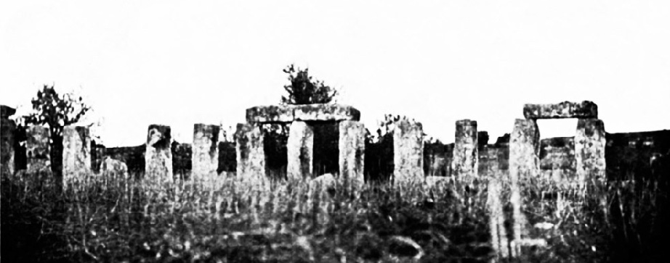
Old photo of trilithons near Tripoli in Libya

The Salisbury Giant Discovered in a Mound, measuring 9 feet 4 inches
In A Theological, Biblical, and Ecclesiastical Dictionary by John Robinson (1830) [10], it describes a 9ft 4in skeleton unearthed a few miles south of Stonehenge in 1719: “…near Salisbury in England, a human skeleton was found, which was nine feet four inches long.” Another source recounts a further clue as to where exactly this huge skeleton came from. It tells of a local woman remembering some details from her childhood in a local publication. The mound was a Giant’s Grave next to St. Edmund’s Church.
This particular church was part of the original college founded by the Bishop of Salisbury, Walter de la Wyle in 1269, and is located a few miles from Stonehenge. The earthwork is located just north of St. Edmund’s Church Yard, now the Arts Centre (founded in 1975), part of the greater Stonehenge landscape. The discovery was published in many sources at the time.
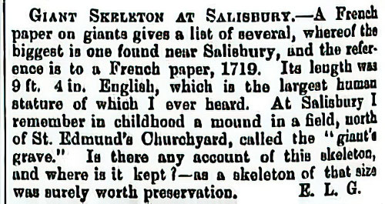
From A Theological, Biblical, and Ecclesiastical Dictionary by John Robinson (1830)

Giant Skeleton near Stonehenge Reported to be 14ft 10in
Thomas Elyot (c.1490–1546) was a diplomat, scholar and Member of Parliament for Cambridgeshire. In his famous Dictionary [11], he states:
“About 30 years since I myself, being with my father, Sir Richard Elyot, at a monastery of regular canons (three or four miles from Stonage) beheld the bones of a dead man found deep in the ground, which being joined together, was in length 13 foot and ten inches, whereof one of the teeth my father had, which was of the quantity of a great walnut.”
In Journey into South Wales (1802) [12] George Lipscomb extends the height of the giant skeleton by one foot:
“…it should be remembered, that Leland, in his ‘Collectanea’, quotes the respectable authority of his friend, Sir Thomas Elyot, as recording, that himself had seen, at someplace, near Salisbury, a skeleton which measured fourteen feet ten inches in length.”
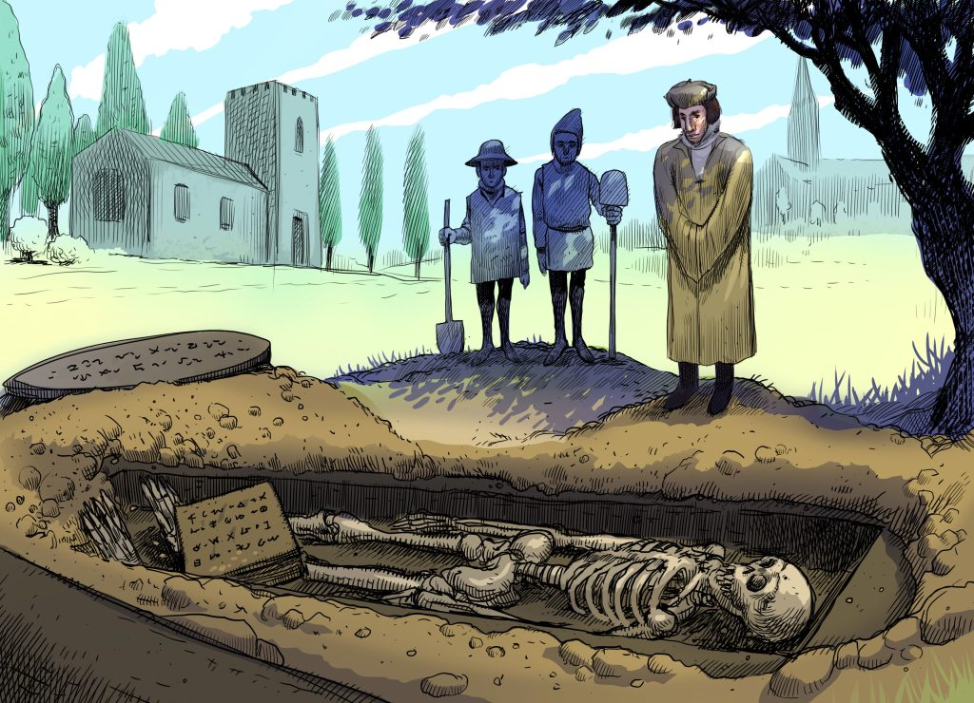
Thomas Elyot observing the giant skeleton, which was found with an ancient book with an unusual script on it. A large inscribed metal disc was found nearby. By Dan Lish.
John Leland wrote De Rebus Britannicis Collectanea [13] in Six Volumes in 1774 and the knighted Sir Thomas Elyot was, like Leland, a respected voice of the time. William Camden [14] evidently alludes to the same incident, though he gives a somewhat different version of it:
“…as a tradition runneth, in our grandfather’s remembrance was found a grave and therein a corpse of twelve foot and not far of a stock of wood hollowed and the concave lined with lead with a book therein of very thick parchment all written with capital Roman letters. But it had lien so long that when the leaves were touched they fouldred to dust. Sir Thomas Elyot, who saw it, judged it to be an Historic.”
We have a 13 ft 10 in skeleton, also recorded as being 14 ft 10 in, and finally a 12 ft one as well, the final account hinting at strange inscriptions on the lead interior. Many different heights are mentioned, but one thing is agreed upon, this was a seriously big skeleton. The log coffin in the final account is very similar to the one described in Glastonbury Abbey, as discovered in the 1100s. Another fact also mentioned by Camden, in speaking of Stonehenge, points to Elyot’s familiarity with this part of Wiltshire and a fascinating artefact that is now lost.
“I have heard that in the time of King Henry the Eight there was found near this place a table of metal as it had been tin and lead commixt, inscribed with many letters but in so strange a character that neither Sir Thomas Elyot nor Master Lilye, Schoole-maister of Paules, could read it, and therefore neglected it. Had it been preserved, somewhat happily might have been discovered as concerning Stonehenge which now lieth obscured.” [14]
The description of a “table” of metal and a mixture of “tin and lead” could be connected to the 12 ft version of the giant account with the mention of the inscribed lead. Whatever it was, and what was written on it, will never be known.

The New Salisbury Giant and the Canaanite Connection
Curiously, in Salisbury, a giant still resides but in a different form. Not skin and bone, but made of textiles and paper mache! Both the Salisbury Giant and Hob-Nob (a hobby horse) were pageant figures created by the Salisbury guild of Merchant Tailors in 1447. The Giant was first recorded in 1496 and even met King Henry VII and his Queen, who were staying at nearby Clarendon Palace.
Many similar “giants” and other pagan models were destroyed during the reformation, but this one survived, being paraded around Salisbury every year on St. John The Baptist’s Day, 24th June. Clearly, this is connected with the Summer Solstice celebrated at Stonehenge, and proves how this tradition survived until recent years. The giant and his minions would parade through the city streets accompanied by great crowds with music and singing, with the heavy thud of a bass drum representing the giant’s footsteps. Hob-Nob always accompanied him, preceding the giant, clearing the path for him so that he did not topple onto the crowds. The pageant had an unsettling and arcane atmosphere, harking back to pagan times.
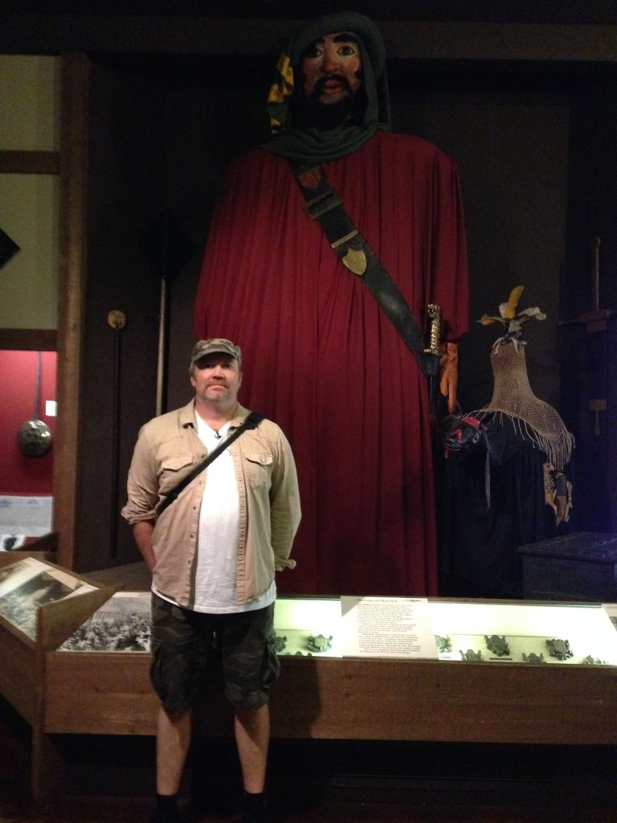
Hugh and the giant effigy on display at the Museum in Salisbury
From 1746 onwards all the giant’s outings were on days of national celebration. The giant was recorded as being a massive 25 feet tall. In 1784 the giant became known as St. Christopher for the first time. In recent times the giant has taken part in celebrations for St. George’s Day (23rd April) that includes an elaborate reenactment of St. George valiantly slaying a dragon. In 2012 the giant made its last appearance on the streets of Salisbury due to a moth infestation in his garments. He has since been retired and is on permanent display in the Museum.
Who really was St. Christopher? According to legends of his life, he was first named “Reprobus” and was a Canaanite from the Bible Lands. He stood at 5 cubits (7.5 feet /2.3m) tall and was said to have a fearsome look about him. He served under the King of Canaan, but felt this wasn’t his true calling and chose to serve “the greatest king there was.” This, of course, was the Messiah who, as an infant, was famously carried across a river by the saint.
As we dug deeper we found more information on the enigmatic St. Christopher, this example from 1876 stated, “This Saint is generally represented as of a gigantic stature.” [15] In The Golden Legend [16], Jacques de Voragine described St. Christopher, “He was of gigantic stature, had a terrifying mien, was twelve coudees tall.” A coudee is an ancient measurement of about the distance from the elbow to the end of the middle finger, often referred to as a cubit. The cubit is usually between 18 and 21 inches long. By these calculations, St. Christopher must have stood from eighteen to twenty-one feet tall. He was also described as having a terrible and fearful voice and countenance.
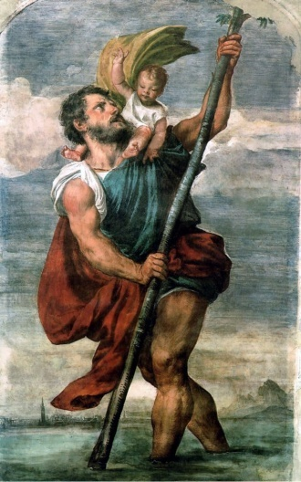
St. Christopher, 1524 by Tiziano Vecellio
A Canaanite giant? In Salisbury? When the authors realised that a giant who was a Canaanite from the Bible lands had been paraded around the nearest city to Stonehenge for hundreds of years, the reality of the association of giants to the great circle suddenly made sense. Why would a secret brotherhood want to maintain this tradition for so long? Had the founders hidden some secret knowledge lost to us in the modern era? It seems they were holding on to this pageant because it encoded certain truths as to the origins of their beloved Stonehenge. Furthermore, the biblical connection cannot go unnoticed and this link with earlier foreign giants might begin to explain other obscure stories regarding the builders of Stonehenge.

Did the “Cangick Giants” build Stonehenge?
Five hundred years after Geoffrey’s Histories, and two hundred years after the Salisbury Giant began being paraded in Wiltshire, Rev. Robert Gay authored A Fool’s Bolt Soon Shot at Stonehenge (1666) [17], about a ferocious prehistoric culture of giant warriors whose earliest incarnations were as semi-divine beings. The Cangi were traditionally the builders of Stonehenge, and although they were based in Somerset, their territory reached Wiltshire. The antiquarian views of Gay did not take hold in the British imagination, but how did these particular giants become known as the builders of Stonehenge?
The story gives an interesting history of a powerful group of warrior giants defeating invading armies, who celebrated by building the great stone ring. Gay wrote:
“some huge bones of men, found amongst others, in the said burrows, as aforesaid, and in other places near Stonehenge.”
Moreover, he stated:
“The Cangick Giants having conquered, triumphed over their enemies…they thought it was expedient to erect this Monument, as their ‘Trophie’. That monument was Stonehenge.”
In his History of Somersetshire [18], Collinson relates that in 1670, while sinking a well in the parish of Wedmore, workers found buried at a depth of thirteen feet the remains of one of the Cangick giants who, according to English tradition, formerly occupied these parts.
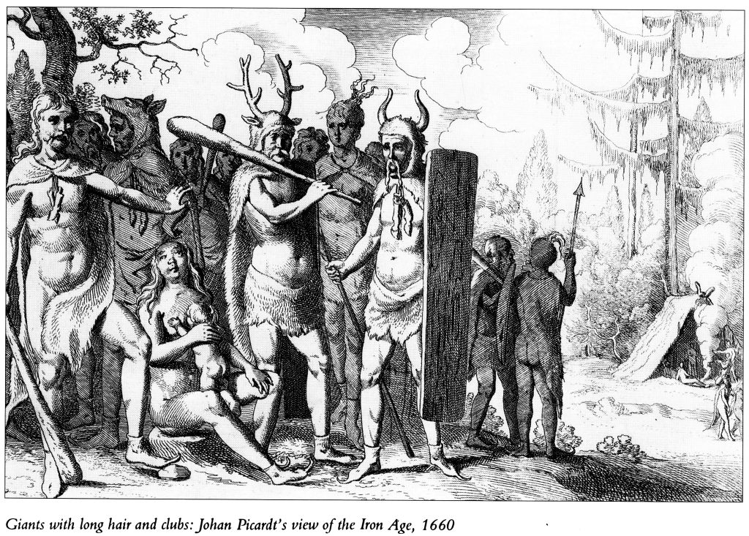
Giants with long hair and clubs. Johan Picard’s view of the Iron Age in Britain c.1660
The origins of the Cangick Giants were not orthodox, with two types of colossi described. One group were called “Giants of Antiquity” who
“had not been borne into the world by the way of all flesh. For they being heathens, and not believing any creation, supposed (to be) the first inhabitants of any nation, were bought forth by the earth… Gigantes.”
This may be a reference to the Nephilim of the Bible, as he made further connections to the Canaanites, not only in name (Canaan = Cangi), or the fact that both had traditions of sacrificing their victims, but also descriptions of skeletal remains that were reported upon at the time.
Stenages (the tribal leader of the Cangi), was thought to be one of ten “principal commanders” of the tribe, all thought to be of giant stature. Noted author William Camden, in his Britannia (1772) stated that the Canaanites of the Bible also appointed ten commanders in their army. Were the Cangi also the inspiration for the creation of the Canaanite giant effigy of St. Christopher in Salisbury?
The Cangi, according to Gay, had metallurgy skills and actually softened, powdered, super-heated and moulded the stones of Stonehenge using “engines.” This hints at advanced technology that may have been inspired by Merlin having used “gears” or “engines” in moving the sarsens from Killarus in Ireland to Salisbury Plain. The softening and manipulation of stone raise an interesting point because over the last two decades Joseph Davidovits, a French materials scientist has been pioneering the theory that many megalithic sites were not constructed, but rather “moulded” using powdered stone.
He claims to have proven that the blocks of the Great Pyramid in Egypt were created in this way with what he calls geopolymer cement. [19] It may also indicate why the mighty sarsens of Stonehenge have what look like “scoop” marks on them as though the stone had been softened then carved before they hardened. This “scooping” technique is also found in Machu Picchu and Ollantaytambo in Peru, and in Aswan Quarry in Egypt.
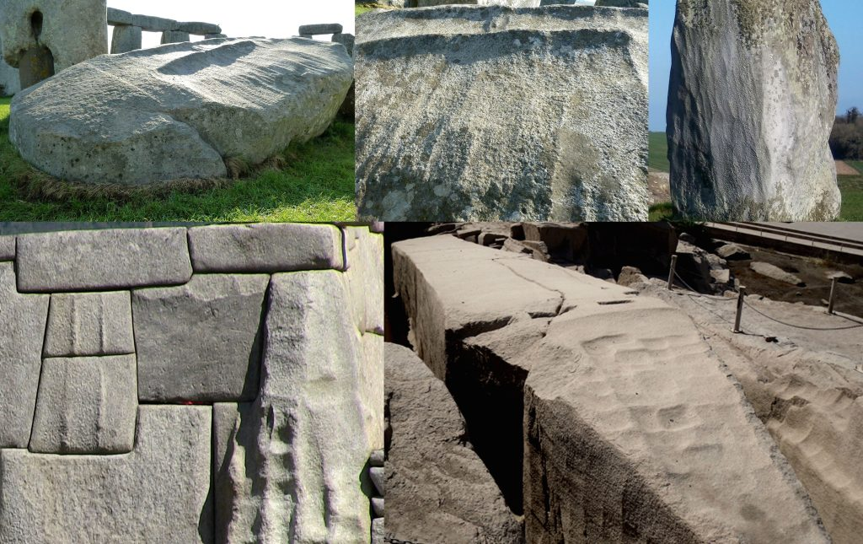
Striations on two of the stones at Stonehenge (three images top) resemble those from Machu Picchu in Peru (lower left) and Aswan Quarry in Egypt (lower right).

The Reality of Giants
Whether in myth, legend, historical documents, massive effigies, or huge bones and skeletons being unearthed, the connection of giants to Stonehenge has been pressed upon the consciousness of this part of Britain for generations. Now, with all the information resurfacing, the age-old legends and myths may prove the famous stone circle had unorthodox origins, quite possibly built by the hands of giants.
The idea of giants having some form of historical reality has largely been regarded as anti-scientific, mythological, naïve and even worse. However, the same can be said for ideas about an ancient cataclysm which now has been scientifically verified in the Younger Dryas boundary event. Also, sites like Göbekli Tepe and Karahan Tepe as well as massive new discoveries in the same area of southern Turkey are proving civilization is much older and more sophisticated than previously imagined.
The point is that science should give more weight to mythology, folklore and oral tradition. Of course, that has to be married to the scientific proof that is needed to validate a hypothesis. We may be entering a time where the subject of giants may become less of a mocked and dismissed idea and more of an accepted reality. After all, the late Pleistocene was a time of mega-fauna and mega-flora, and just maybe, mega-sized humans.
- Edited by John D. Keyser

References:
[1] Avalon Rising Publications (October 12, 2021).
[2] https://www.sciencedirect.com/science/article/pii/ S2666675821000552?via%3Dihub
[3] https://www.bbc.com/news/science-environment-57432104
[4] Penguin Books, First Edition (January, 1977).
[5] Oxford University Press, April 11, 2024.
[6] Compendium of World History, vol. II, pp.113-115.
[7] Vol. 1. The Irish Texts Society, London. 1902, pp. 179 & 183.
[8] Megalithomania, by John Michell. Cornell University Press, N.Y. 1982, p.102.
[9] Samuel Danyel, Stonehenge: A Poem, 1624.
[10] A Theological, Biblical, and Ecclesiastical Dictionary: Serving as a General Note-Book and Illustrative Commentary of the Old and New Testament, and as a Cyclopedia of Religious Knowledge. ‎ Forgotten Books Publisher (August 24, 2018).
[11] Dictionary, 1538 (English linguistics, 1500-1800; a collection of facsimile reprints). Scholar Publishers, January 1, 1970.
[12] Journey Into South Wales, Through the Counties of Oxford, Warwick, Worcester, Hereford, Salop, Stasfford, Buckingham, and Hertford; in the Year 1799. Wentworth Press ( August 28, 2016).
[13] de Rebus Britannicis Collectanea (Latin Edition). ‎ Farnborough: Gregg Reprints; New edition of 1774 edition (January 1, 1970).
[14] Britannia: Or, a Chorographical Description of the Flourishing Kingdoms of England, Scotland, and Ireland, and the Islands Adjacent: From the Earliest Antiquity. ‎ Gale Ecco, Print Editions (April 25, 2018).
[15] St. Christopher, Martyr, by Father Francis Xavier Weninger, 1876.
[16] The Golden Legend: Readings on the Saints. ‎ Princeton University Press; Reprint edition (April 22, 2012).
[17] Rev. Robert Gay, A Fool’s Bolt Soon Shot at Stonehenge, 1725, in Rodney Legg, Stonehenge Antiquities, Dorset Publishing, 1986.
[18] John Collinson, The History and Antiqutities of the County of Somerset. ‎ Forgotten Books (August 24, 2018)
[19] www.geopolymer.org/archaeology/

Hope of Israel Ministries – Paving the Way for the Return of YEHOVAH God and His Messiah!
Hope of Israel Ministries P.O. Box 853 Azusa, CA 91702, USA www.hope-of-israel.org |  | Scan with your Smartphone for more information

