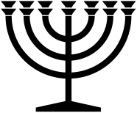 |  | October 2024
Sunday | Monday | Tuesday | Wednesday | Thursday | Friday | Saturday
 |  | 1 | 2 | 3 | 4 | 5
 |  |  |  | S | NM | Trumpets  NM
6 | 7 | 8 | 9 | 10 | 11 | 12
 |  |  |  |  |  | S
13 | 14 | 15 | 16 | 17 | 18 | 19
 | Atonement  (Yom Kippur) |  |  |  |  | Tabernacles  S  FOT-1
20 | 21 | 22 | 23 | 24 | 25 | 26
FOT-2 | FOT-3 | FOT-4 | FOT-5 | FOT-6 | FOT-7 | Last Great Day  S
27 | 28 | 29 | 30 | 31
RED = Sabbath BLUE = New Moon YELLOW = High Day or High Day & Sabbath or New Moon GREEN = Feast of Tabernacles www.hope-of-israel.org

