The Giants of Ancient Egypt

The more we explore the records of ancient Egypt the more we find that the royal bloodlines of the early rulers were exceptionally large and responsible for the massive structures still standing today.

by Hugh Newman
A recent article titled “Ancient Egyptian Pharaoh May Be the 1st Known 'Giant,'” published in Live Science on August 4th, revealed that 3rd Dynasty Pharaoh Sa-Nakht, excavated from Wadi Maghareh (located in the Sinai Peninsula region), was a so-called “Giant” -- the first known giant ruler of ancient Egypt. He was 5 inches taller than the robust Ramses II, and 8 inches taller than average man for that time. Although he was only 6ft 1.5in tall, this caused a media sensation, but please note that I am the same height as this “giant”!
Throughout Egypt’s past there have been numerous examples of much taller giants reported, excavated, depicted in art, and mummified examples that have been hidden from the public. We have uncovered accounts ranging from between seven feet (2.13 meters) and sixteen feet (4.88 meters) tall. Painstaking research of archaeological records, archaic texts, newspapers, and analysis of depictions of hieroglyphs and Egyptian art has started to shed some light on this phenomenon.
The whole area of the Middle East has strong legends of giant humans, along with references in the Bible -- which include Moses fleeing from Egypt and being attacked by the mighty Canaanites in current day Israel and Lebanon. Notice what the Bible records:
“Yet again there was a battle in Gath, where there was a man of great stature, who had six fingers on each hand and six toes on each foot, twenty-four in number; and he also was born to the giant” (2 Samuel 21:20).
Newspaper accounts confirm the reality of these tribes, and skeletons and bones of enormous proportions have been unearthed in this area of the Bible Lands, and also in other parts of Africa and the Middle East.
The unfolding discoveries of “giant skeletons” reported in America and other parts of the world has revealed a lost legacy of a race of colossi, who are now slowly starting to be included in the historical and archaeological record. Egypt is no exception, and my co-author Jim Vieira and I have been collecting accounts for the last few years that for the first time are revealed in this article.

Did Giants Build the Great Pyramid?
The ruling elite of prehistoric Khemit were always seen as super-humans, some with elongated skulls, others said to be semi-spiritual beings, and some described as giants. An archaic legend recounts that the Giza Pyramids may have been built by a race of giants. It was shared in a lecture by occultist and Freemason Manly P. Hall (probably recorded in the 1980s) and giantologist Kristan T. Harris put it out on a Youtube video. It was originally part of a lecture titled Atlantis and the Gods of Antiquity.
“We are told that in the year 820 AD…way back in the days of the glory of Baghdad, the great sultan, the follower and descendant of the great El-Rashid of Arabian Nights, the Sultan El-Rashid Al-Ma’mun, decided to open the Great Pyramid. He had been told that it had been built by giants, who were called the Sheddai, superhuman beings, and that within that pyramid and those pyramids, they had stored a great treasure beyond the knowledge of man.”
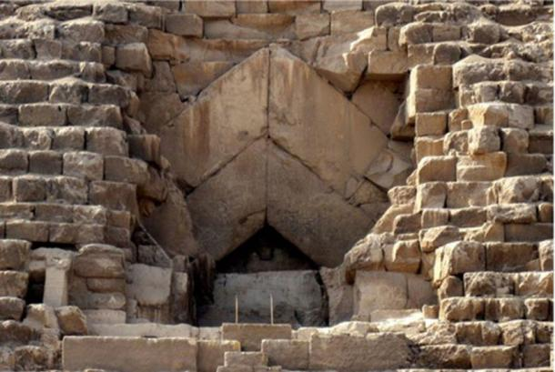
The “entrance” to the Great Pyramid that was entered in 832 AD. (Olaf Tausch/CC BY 3.0)
It is true that in 832 AD Al-Ma’mun traveled to Egypt and was the first “excavator” of the Great Pyramid, at a time when it was completely encased in white limestone blocks. Who the Sheddai are is another mystery, but could be referring to another name of the Shemsu Hor, or “Followers of Horus”. It could also refer to Shaddād bin 'Ad (King of Ad), who was believed to be the king of the lost Arabian city of Iram of the Pillars, an account of which is mentioned in Sura 89 of the Qur'an. He is sometimes referred to as a giant.
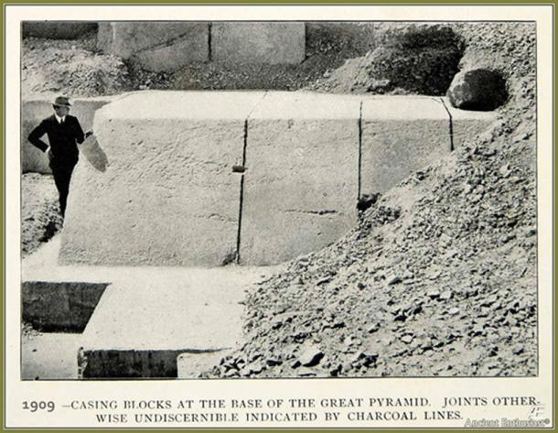
The massive casing stones of the Great Pyramid. In 832 AD the entire pyramid was still covered with them. (Author provided)

The Giants of ‘Ad and Megalithic Construction in Egypt
The Akhbār al-zamān, also known as The Book of Wonders​ (ca.900 - 1100 AD), is an Arabian compilation of medieval lore about Egypt and the world before the Great Flood. It claims that the people of ’Ad were giants, so Shaddad was most likely one, and it is said he “built the monuments of Dahshur with the stones that had been carved in the time of his father.” Before this, the giant Harjit had begun its construction. At a later date, Qofṭarīm, another giant, “placed secrets in the pyramids of Dahshur and other pyramids, to imitate what had been done of old. He founded the city of Dendera.” Dashur consists of the Red Pyramid and Bent Pyramid constructed during the reign of Pharaoh Sneferu (2613-2589 BC). Dendera consists of highly decorated pillars dedicated to the Goddess Hathor.
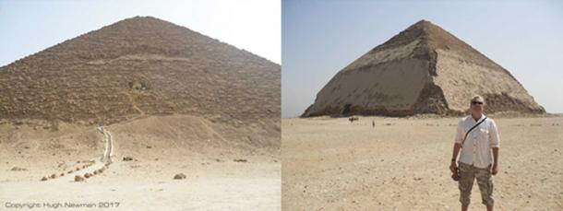
The Red Pyramid and Bent Pyramid of Dashur, with the author standing in front. Photos by Hugh Newman.
The text goes on to say that Naqraus, the first king of Egypt (after the flood), with his companions “built monuments, erected high towers, and executed the wonderful works,” while the city of Memphis was the work of a later set of giants, who worked for King Misraim, another giant. Even later still it describes the work of more of these colossi: “Adīm was a giant, with insurmountable strength, and the greatest of men. He ordered the quarrying of rocks and their transportation to build pyramids, as had been done in former times.”
So what do we make of these stories? It does seem that Manly P. Hall was aware of this text and attempted to summarize it in his lecture. It is the opinion of the author that all ancient “lore” is worth acknowledging as many of these traditions were relied on to carry knowledge and wisdom through the generations.

Were the “The Followers of Horus” Giants?
The Followers of Horus, who were said to have created the primordial mound at Giza, long before the Pharaohs built the first pyramids, are sometimes recorded as giants. Early archaeological excavations in Egypt point to that reality:
“Towards the end of the IV millennium BC the people known as the Disciples of Horus appear as a highly dominant aristocracy that governed entire Egypt. The theory of the existence of this race is supported by the discovery in the Predynastic tombs, in the northern part of Higher Egypt, of the anatomical remains of individuals with bigger skulls and builds than the native population, with so much difference to exclude any hypothetical common racial strain.”
Professor Walter B. Emery (1903-1971) was the Egyptologist who excavated Saqqara in the 1930s and discovered Predynastic remains there. These had dolichocephalous skulls, larger than those of the local ethnic group, fair hair and a taller, heavier build. Emery announced that this stock wasn't indigenous to Egypt but had performed an important sacerdotal and governmental role in the country. This group kept its distance from the common people, blending only with the aristocratic classes and were thought to be part of the Shemsu Hor, the “disciples (or followers) of Horus.”
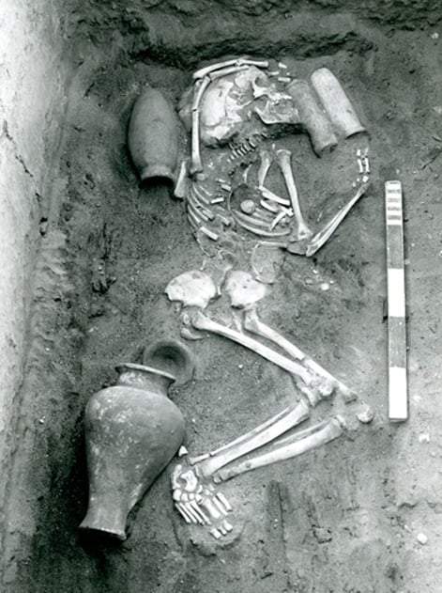
Early excavation at Saqqara showing a typical burial. (Egypt Exploration Society)
Author Freddy Silva also uncovered a tantalizing description of these ‘giant gods’ in the Edfu Building Texts:
“Advice to initiates in the temple of Edfu offers a glimpse as to what the builder gods may have looked like, since the initiates were instructed to “stand up with the Ahau” (‘Gods who stand up’) who measured 9 cubits tall. That’s approximately 15 feet or 4.6 meters!”

Giant Artifacts of the First Pharaoh
The first Pharaoh of Egypt (c.3150 BC) was called Menes (or Narmer), but is more famously remembered as “The Scorpion King.” There is no record of his stature, but he is depicted as being very tall on the famous Narmer Palette (c.3100 BC) and during his reign oversized artifacts were created and are now preserved in a museum in Oxford, England.
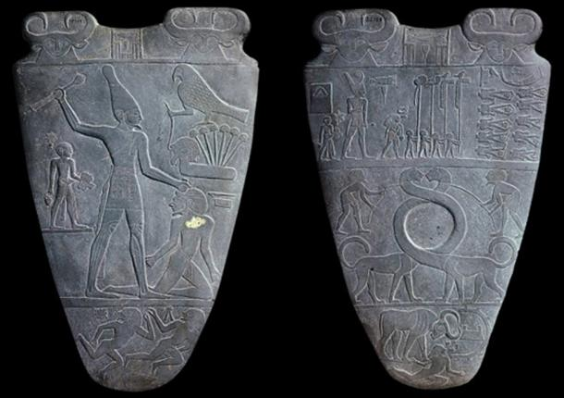
The Narmer Palette that shows the giant king defeating his enemies. c.3100 BC. (Public Domain)
In July 2017, I visited the Ashmolean Museum to investigate the mysterious Scottish carved stone spheres, but I took some time to look at the Egyptian exhibition. To my surprise there was an obvious giant artifact from the first dynasty and a statue of a giant pharaoh from the second dynasty who was believed to be over eight feet (2.44 meters) tall.
In the central display cabinet, a strange object caught my eye as it clearly did not look Egyptian. The shape was exactly the same as an Australian Boomerang, so I read the information board and it described it as a “throwing stick.” The Australian-Egyptian connection is a fascinating area of research, as I have visited the Gosford Hieroglyphs north of Sydney that may indicate early contact between these cultures.
In the same glass case were some beautifully carved flint knives, but there was one so large I did not notice it at first, as it took up nearly the full width of the cabinet. It was at least ten times bigger than the others and it looked like it had been “used” as a knife. The information panel says it was “probably ceremonial” as that is the only way to explain its massiveness. It was discovered in Hierakonpolis, underneath the foundations of a later temple from the first dynasty. Why it was deliberately buried and hidden so thoroughly is unknown, but it was perhaps in a ceremonial way to honor the gods, who were quite possibly giants.
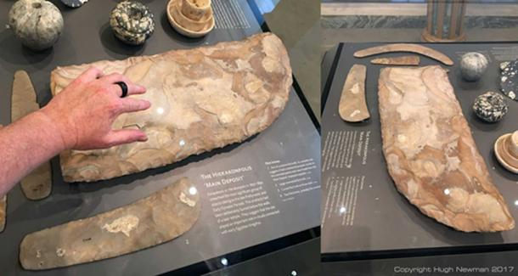
Oversized flint knife at the Ashmolean Museum said to be “ceremonial.” Photos by Hugh Newman.
In the opposite display case, some oversized mace-heads that were once in the possession of the legendary “Scorpion King” caught my attention in the corner of the Antiquities of Egypt room. Again, they were described as ceremonial, but could they have been the correct size, designed for giant kings?
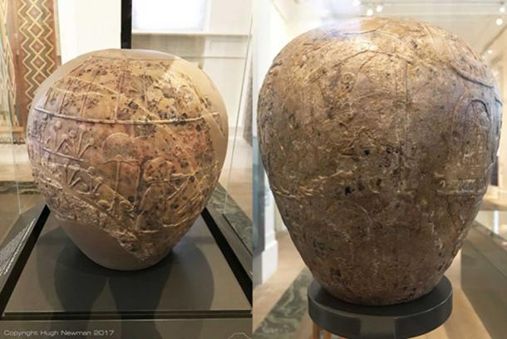
Limestone mace-heads that are oversized versions of the small stone weapons that were typical grave goods during the Predynastic period. They became symbols of the Egyptian elite by 3100 BC. Photos by Hugh Newman.
I will now go on to consider the giant individuals from Egypt, including Pharaohs who were 8 feet (2.44 meters) tall, (over two and a half feet taller than the norm and unusually lofty even by today’s norms), representations of giants, the over-sized sarcophagi and more reported giant skeletal finds.

A Giant King over 8 Feet Tall
King Khasekhemui (also spelled Khasekhemwy and Khasekhem, ca. 2690 BC) was the final ruler of the Second Dynasty of Egypt based near Abydos and was involved in the construction of Hierakonpolis, the Predynastic capital. This is the same site where the previously mentioned gigantic knife was discovered. He was buried at the necropolis at Umm el-Qa'ab in what was once described as the earliest stone structure in Egypt. The large limestone tomb was not sophisticated in any way and when Prof. Robert Temple investigated the site in 2001 he was amazed that the quality of the construction was so primitive. Especially compared to the step pyramid of Djoser at Saqqara, which has been dated to the start of the third dynasty, just a few years later. Djoser was also thought to have “buried” Khasekhemui at this site before moving north to the area of Saqqara.
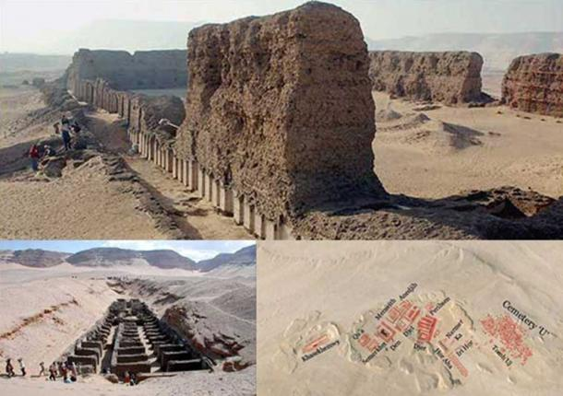
Top: Mortuary buildings at Hierakonpolis. Bottom: The burial site and map of cemetery. Courtesy Google Earth and “Odyssey, Adventures in Archaeology”
Khasekhemui’s skeleton was never found, suggesting it was looted long before the excavation. The Second Dynasty King is unique in Egyptian history as having both the symbols of Horus and Set on his serekh. Some Egyptologists believe that this was an attempt to unify the two factions, but after his death Set was dropped from the serekh permanently. He was the earliest Egyptian king known to have built statues of himself.
But the most startling thing about this Pharaoh was the fact that he was something of a giant. Flinders Petrie, who first excavated the site, found evidence from the 3rd Century BC that he was “…5 cubits and 3 palms high, which would be about 8 English feet (2.44m), if the short cubit of 17.4 inches were used.” In the most recent translation of Manetho it is said: “He was five cubits and three palms (eight and one-half feet) tall.” Manetho is believed to have been an Egyptian priest from Sebennytus who lived during the Ptolemaic era in the early 3rd century BC and he wrote about this giant in Aegyptiaca (Αἰγυπτιακων), or History of Egypt, a book written at the request of Ptolemy II Philadelphus.
However, if we use the “Royal Cubit” his height increases to 14ft, 7in (4.45 meters) tall. Considering he was a “King” perhaps the “Royal” cubit should be considered, but this kind of stature is well out the normal range of humans, so although tantalizing and correlating with other accounts, the more conservative height range of 8ft to 8ft 6in (2.44-2.6 meters) is much more likely. A statue of him is on display at the Ashmolean Museum in Oxford, but it does not give details about how tall he was.
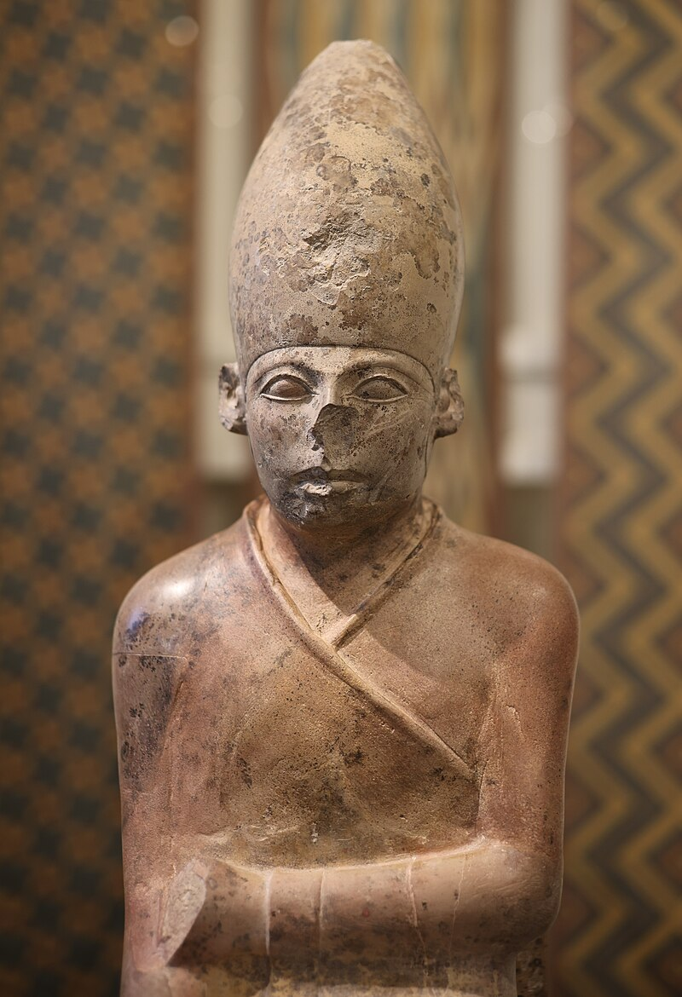
Limestone statue of Khasekhemui at the Ashmolean Museum in Oxford.
Pharaoh Khasekhemui was said to have ruled for 48 years and united Upper and Lower Egypt during his reign. Perhaps he was feared, as a king of this stature must have been very influential and towered over his contemporaries and his enemies. It is also important to note that the earliest inscriptional evidence of an Egyptian king at the Lebanese site of Byblos belonged to the reign of Khasekhemui.
Being very close to Abydos and the earlier sunken temple called the Osirion, can we consider he was involved in its superior construction? This would certainly explain how such massive blocks could have been moved into place, but the primitive stonework of his reign is inconsistent with this.
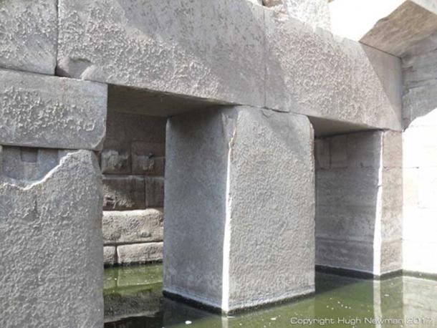
The Osirion at Abydos showing sophisticated stone construction. Photo by Hugh Newman.
Interestingly the famous Abydos King List is carved on the Seti l Temple at Abydos and depictions from the 19th Dynasty shows a larger than life Seti represented as about 8 feet (2.44 meters) tall. In a strange twist, Khasekhemui was omitted from the final list, as were certain other early notable kings, who were apparently considered illegitimate.
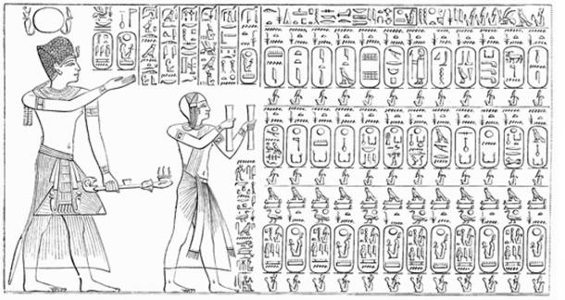
The Abydos King List is a list of the names of seventy-six kings of Ancient Egypt, found on a wall of the Temple of Seti I at Abydos, Egypt. This list omits the names of many earlier pharaohs, such as Khasekhemui. (Public Domain)

Depiction of a Giant at Saqqara
The Third Dynasty saw the great pyramid of Saqqara built with numerous other temples in the complex. Djoser, who buried the gigantic King Khasekhemui (and may have been his son), was the ruler of Saqqara during its construction. Within the complex a painting of a giant who clearly appears to have an elongated skull was photographed with Egyptologist Zahi Hawass examining it. He does not look too pleased! However, this could be a depiction of the skeletons that were excavated by Emery in the 1930s of “individuals with bigger skulls and builds larger than the native population”?
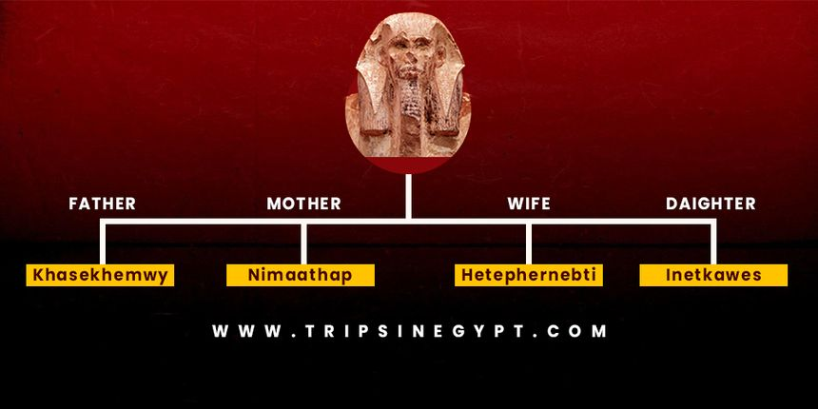
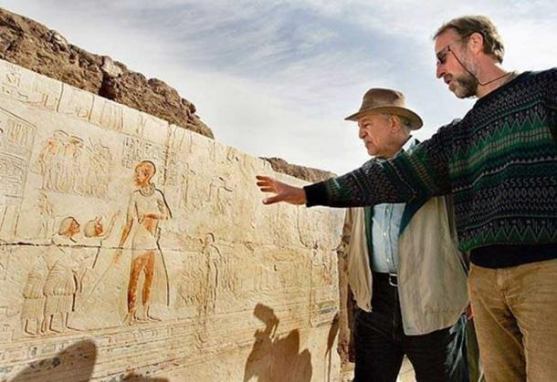
Zahi Hawass and archaeologist inspecting a depiction of a possible giant at Saqqara in 2007. Courtesy AP Photo / Ben Curtis.

The Giants of the Temple of Isis
This unusual story was reported in multiple newspapers in 1895 and 1896, but we feature the earliest and most complete version. The photo is a reconstruction of the Temple of Isis, where the account originated from.
It originally appeared in The Arizona Silver Belt., November 16th, 1895 with the headline “Prehistoric Egyptian Giants”:
"In 1881, when professor Timmerman was engaged in exploring the ruins of an ancient temple of Isis on the banks of the Nile, 16 miles below Najar Djfard, he opened a row of tombs in which some prehistoric race of giants had been buried. The smallest skeleton out of some 60 odd, which were examined during the time Timmerman was excavating at Najar Djfard, measured seven feet and eight inches in length and the largest eleven feet one inch. Memorial tablets were discovered in great numbers, but there was no record that even hinted that they were in the memory of men of extraordinary size. It is believed that the tombs date back to the year 1043 B.C."
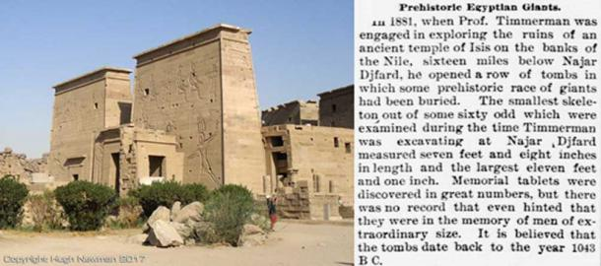
The Temple of Isis on Philae Island with the newspaper account detailing the discovery of giants. Photo by Hugh Newman.
There is no more information about this report, but it was repeated in The Arizona Weekly Citizen, February 1st, 1896, and several other newspapers.

Mummified Finger of 16ft Tall Giant
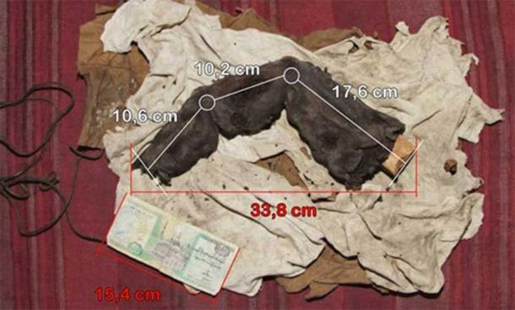
Photo of the mummified finger with measurements, courtesy of Gregor Sporri.
According to the German newspaper, BILD.de, a Swiss nightclub owner named Gregor Spörri took a number of photos of a mummified giant finger in 1988. The owner was a retired grave robber who was based in the district of Bir Hooker, near Sadat City, about 100 KM (62.14 miles) north of Cairo. The finger is nearly 14 inches (35cm) long and, if it is genuine, it belonged to someone estimated to have been between 15 and 16 feet (4.57-4.88 meters) tall (or someone with oversized hands!).
However, the discovery was only revealed on March 9th, 2012, twenty-four years later, and since then there has been no official rebuff of the discovery. Nagib told Gregor that it was found about 150 years ago and had been kept in the family, who had even gone to the trouble of getting the finger X-rayed to confirm its authenticity in the 1960s. Spörri had to pay 300 dollars to see the mummified finger and take pictures of it.
“Nagib refused to tell Spörri where the finger was found but made allusions to a hidden room in the basement of the Great Pyramid where huge, empty graves are located. Nagib made it clear that the relic was not for sale as it was too important for Nagib's family. Before he returned to his hotel, Spörri took a number of photos where he put a banknote next to the finger in order to indicate the size.”
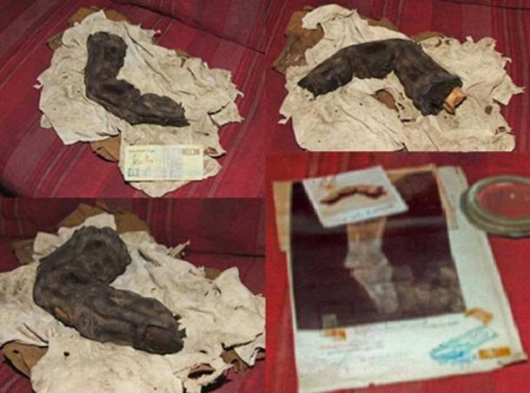
More images of the finger, including an x-ray that was done in the 1960s. Courtesy Gregor Sporri.
The problem is, nineteen years later he went back to Egypt to locate the gentleman, but he could not find Nagib and no one knew where he was. A DNA sample would have been useful, but the X-ray, the detailed photographs, and his thorough description do hint that this was a genuine mummified finger.
“Spörri observed the finger in detail and was able to determine that what he was holding was old, organic and humanoid. The finger looked like it had been cut off with anatomical precision, and in some places was crumbled. The leathery skin was ripped in places and the skin was a few mm thick. Between the dried skinfolds he could see remains of fungus and the nail was loose. The surface of the skin was damaged in some places, as if mice had gnawed on it. The bone felt woody.”
The photos and X-rays were examined by professionals who could see no evidence of fakery.

Million-Mummy Cemetery Reveals 7ft Skeleton
A cemetery called Fag el-Gamous, which means Way of the Water Buffalo, and a nearby pyramid have been excavated by archaeologists from Brigham Young University for the last 30 years. Many of the mummies that were discovered date to the time when the Roman or Byzantine Empire ruled Egypt, from the 1st century to the 7th century AD. The pyramid, however, may date to about 2500 BC, the time the Giza pyramids were being constructed.
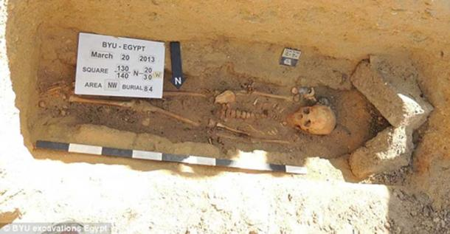
Burial from Fag el-Gamous. Courtesy of BYU Excavations.
"We are fairly certain we have over a million burials within this cemetery. It's large, and it's dense," Project Director Kerry Muhlestein, an associate professor in the Department of Ancient Scripture at Brigham Young University, said in a paper he presented at the Society for the Study of Egyptian Antiquities Scholars Colloquium, which was held in November 2014 in Toronto. However, it is now thought (as of 2017) that it is more likely to be tens of thousands of graves.
One discovery that never got officially published was that of a mummy who was more than 7 feet (2 meters) tall. "We once found a male who was over 7 feet tall who was far too tall to fit into the shaft, so they bent him in half and tossed him in.”
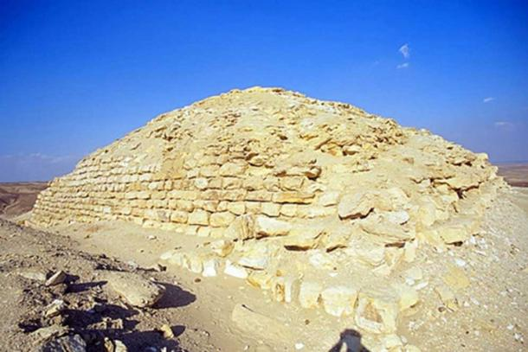
The small pyramid that dates to around 2,500 BC, the same era as the Great Pyramid of Giza. Courtesy of BYU Excavations.
This amount of burials next to such a small settlement has raised many questions, especially because the pyramid is at least 2,500 years older than the cemetery, contemporary with Saqqara and the earliest phases of the Great Pyramid. The huge quantity of bodies that ended up here remains a mystery. Were they brought in from other areas because this was a sanctified zone? Or is there another reason? Either way, within days of this story going to press, the archaeologists were told to halt excavations by Egyptian officials and their licenses to dig were revoked. “The department will suspend any archaeological mission if its director neglects to ‘immediately’ notify the office of any new discoveries,” the rules stipulate. Was it halted because they were revealing the giants of ancient Egypt to the world?
There was no indication if the giant mummy had any signs of gigantism, but it gives yet more credence to the idea that giants did live and thrive in ancient Egypt whether they were Pharaohs with elaborate burials, or folded up and thrown down holes in the desert.

Giants in Egyptian Art
In this next image, we can see various examples of Egyptian inscriptions and art that appear to represent giants next to people of smaller stature. Some caught my attention, whilst others could simply be adults with children, or art to glorify themselves.
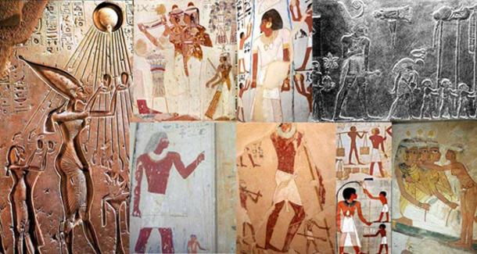
Various depictions of giants in Egyptian art collected by Muhammad Abdo. Courtesy Muhammad Abdo.
The researcher Muhammad Abdo compiled most of the images in the above compilation. Please take a look for yourself, as it is difficult to tell if these are realistic depictions or artistic impressions, but they are worth noting anyway.

Giant Sarcophagi of Egypt
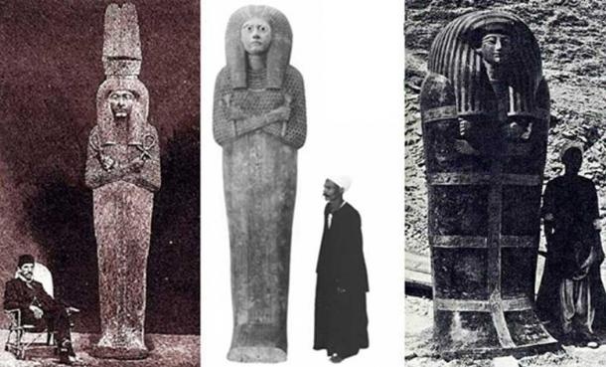
Three examples of massive coffins from ancient Egypt. Courtesy Muhammad Abdo
According to some researchers, gigantic coffins are proof of giants in Egypt. I have seen a few on my travels, but it simply could be the case that they made them bigger than required to impress others or to make it clear to the gods in the afterlife that they were of royal stock. Some examples, however, do pose a few awkward questions.
The Serepeum near Saqqara is composed of 25 massive granite and diorite coffins weighing up to 70 tons each and mummified Apis Bulls were sealed in them as part of an ancient cult. One bull was found, but only one, which has led to speculation that the rest of them were once used for giant humans.
Another huge sarcophagus is located under the Giza Plateau in what is called the “Osiris Shaft.” It is partly submerged under water, is rarely visited or photographed, and is deep beneath the stone causeway of the so-called Khafre’s Pyramid.
The alabaster coffin of Seti l is 9ft 4in (2.84 meters) long and is currently housed in the Soane Museum in London. He was also the larger than life figure as depicted on the Abydos King Lists and with the massiveness of his coffin, you would jump to the conclusion that he must have been a very tall Pharaoh.

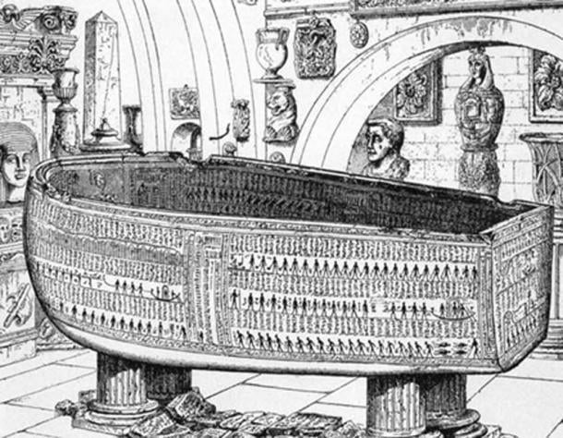
The 9ft 4in alabaster coffin of Seti l now on display at the Soane Museum in London. From Sarcophagus of Seti I, King of Egypt, B.C. 1370 by E.A. Wallis Budge, Sir John Soane's Museum. 1908.
However, his mummy was also discovered, and it measured 5ft 7in (1.7 meters) tall, so even though there are giant coffins and artistic impressions of very tall Egyptians, it does not mean they represent actual human giants.

Gigantism in Ancient Egypt
We began our survey with, well, the smallest giant discovered in ancient Egypt, who just happens to match my height of 6ft 1.5in. (1.87 meters) Even at this meager height, Michael Habicht and his colleagues have concluded that Sa-Nakht probably suffered from gigantism after they reanalyzed the alleged skull and bones of the Pharaoh. They said: “The skeleton's long bones showed evidence of ‘exuberant growth,’ which are clear signs of gigantism."
So this is the real reason he got labeled a “giant”, not because of his staggering stature. “In fact, he probably wouldn’t have been tall enough to make a basketball team today -- a typical NBA center stands in the 7-foot range.” There are very few accounts of gigantism in the historical record, so this is interesting in and of itself. Most of the accounts seem to indicate a normal human skeletal frame, without signs of any pituitary gland irregularity.
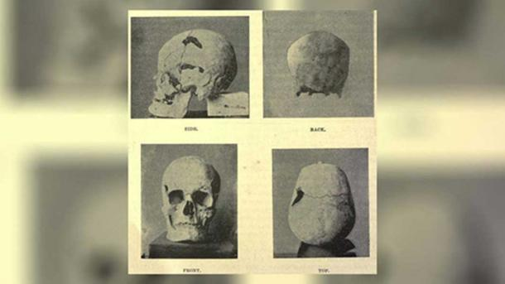
Suffering from gigantism, Sa-Nakht was 6ft 1.5in tall, but on the lower height scale of “giants” featured in this article. Courtesy of Live Science.
Anyway, with these discoveries presented in this article, it simply builds the case for the existence of giants in prehistoric Egypt and around the world, and the more we explore the records of each country, the more examples we find. Some of those included in this article are not particularly tall, but it does strengthen the idea that those who were born with giant genes were honored and respected and were part of the royal bloodlines of the very early rulers of ancient Egypt. It may even shed light on how such large stones were quarried and lifted in to place, as only giants, very advanced technology, or ingenious architects, could have achieved such a gargantuan task.
Edited by John D. Keyser

Hope of Israel Ministries – Paving the Way For the Return of YEHOVAH God and His Messiah!
Hope of Israel Ministries  P.O. Box 853  Azusa, CA 91702, USA  www.hope-of-israel.org |  | Scan with your Smartphone for more information

